Project Design Phase-II Customer Journey

|  |  |
| --- | --- |
| Date | 08 October 2022 |
| Team ID | PNT2022TMID39010 |
| Project Name | Signs with smart connectivity for better road  safety |
| Maximum Marks | 4 Marks |

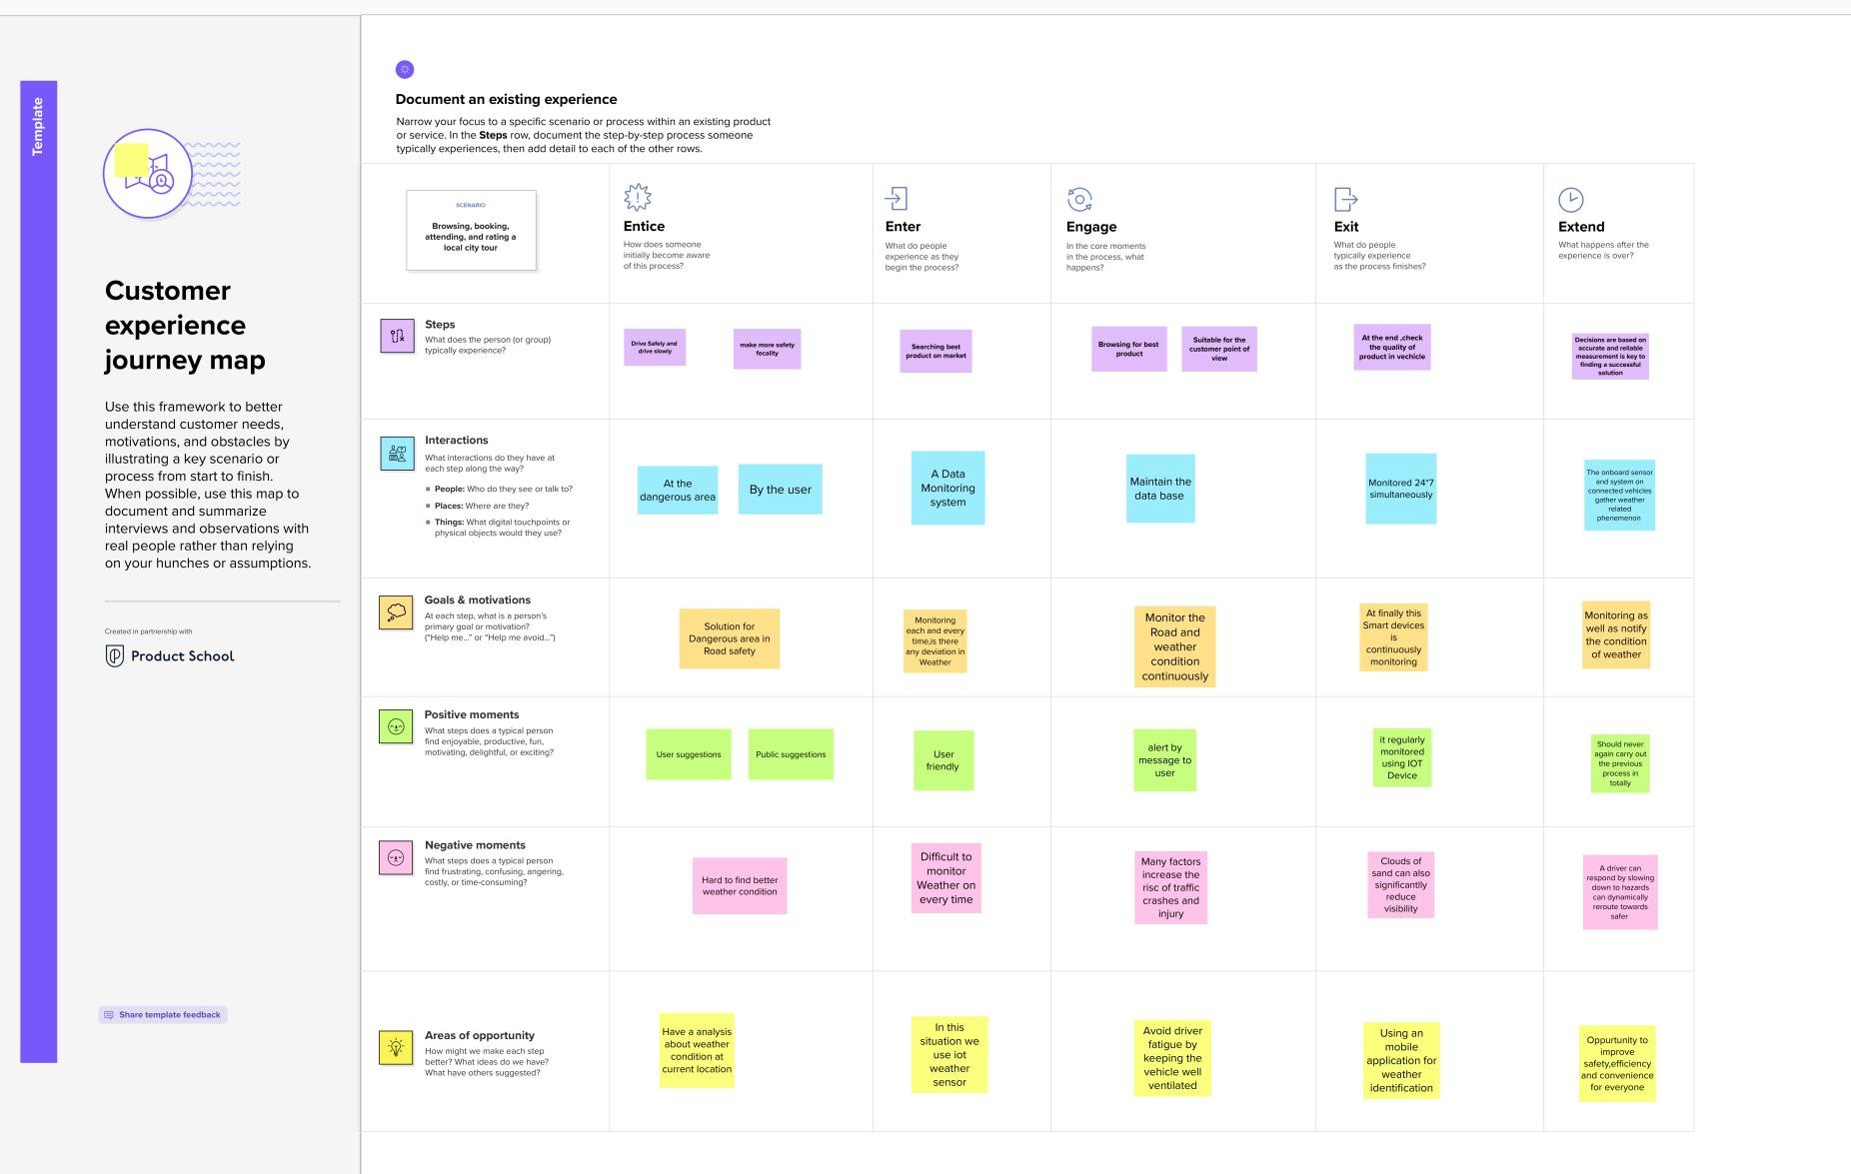Customer Journey: